APACHE MAVEN
Apache Maven is an open-source software project management tool that helps the developer in the creation, building, and management of Java-based projects.
Maven is often considered to be an Intelligent, Comprehensive, Project management and also as a Build tool for the following features:

Feature | Description
Intelligent | During the build process, when a certain life-cycle phase is triggered, Maven makes sure to trigger the previous phases before coming to it.
Comprehensive | A single product is capable of managing a project right from the creation till deployment
Project Management | Manages the dependencies required for a project and also helps in creating project documentation sites to have a well-defined collaboration among the team members
Build | Builds a project and derives distribution unit out of it (jar/war/ear)
Developers usually prefer Maven in their projects for the following reasons:
- Standard enforcement: Maven emphasizes a well-defined project structure for all types of Java projects.
- Provides Project Configuration: The heart of any Maven project is a configuration file which includes the dependency information needed for the various build activities. Adding these dependencies is easier. Typically, this configuration file is placed at the root folder of any Maven project.
- Well defined life-cycle: Maven-based Java projects have a series of stages involved in a project build which constitute the build life-cycle. The three-built-in life-cycles are clean, default (build), and site.
- Creates and uses local-repository: Maven downloads the initial set of dependencies and support artifacts required for the project from remote repositories and stores them in a local machine. A local repository is a place located in the local machine where these artifacts (eg: jars) are available for future use. Maven uses the local repository for resolving the dependencies required by various projects.

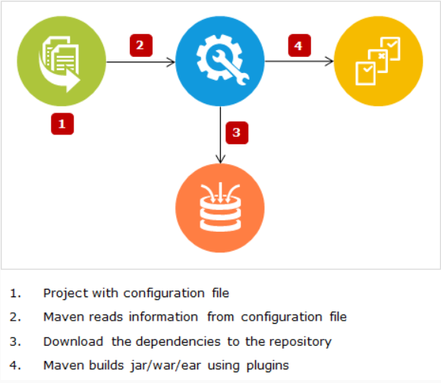

Now let us understand what information it conveys to the developers.
Directory | Description
infycart/pom.xml | The configuration file of Maven which is responsible for defining the project, organizing plugins and mentioning the dependencies that are needed for the project
infycart/src | It is the root directory which consists of source code and test cases
infycart/src/main/java | By default, the source code (Java classes) of the project is expected to be written inside this directory by Maven
infycart/src/test/java | By default, the test cases written using Junit or TestNG are expected to be written inside this directory by Maven
infycart/src/main/resources | The necessary classpath resources required for the source code are expected inside this directory by Maven. eg: .properties or .yml files
infycart/src/test/resources | By default Maven looks for necessary classpath resources required for the test cases inside this directory. eg: .properties or .yml files
infycart/target | This is created by Maven and contains the build outcomes
infycart/target/classes | Contains the .class files of the source code
infycart/target/test-classes | Contains the .class files of the test cases
Note : For any project, externalizing the configurations is completely optional. Hence, the .properties or .yml or .xml files might or might not exist and IDE might not create ${basedir}/src/main/resources or ${basedir}/src/test/resources by default. However, we can create this folder explicitly, if required and place the appropriate contents here.
Eclipse does not create the src/main/resources by default, but IntelliJ does.

What is POM?
- Project Object Model is the most important, logical unit of work in any Maven project.
- It is basically an XML configuration file named pom.xml with the information about project and the necessary configurations.
- pom.xml is often described as the declarative descriptor of Maven projects. It is mandatory for this file to be placed in the root folder of the project.
- It not only describes what to build, but, how to build as well.

Maven searches for POM in the base folder that mentions the type of the project and provides the details like project name, customizations about the build, how to execute a task, plugins should be used and so on.
Once Maven gets this configuration information, it starts executing the task based on the command given. The default pom.xml is provided by Maven’s archetype plugin which contains the basic set of dependencies.

A Maven project's pom.xml has the following sections:
- Project Information: Mandatory section which contains the project co-ordinates to uniquely identify the project.
- Dependencies: Optional section which refers to the libraries/artifacts/jars needed for the application.
- Build Plugin: Optional section which refers to the plugin configurations needed for the application.
- Build Profile: It is an optional section. This section usually has the various configuration settings using which the build can be customized for different environments - production, test, development, etc.
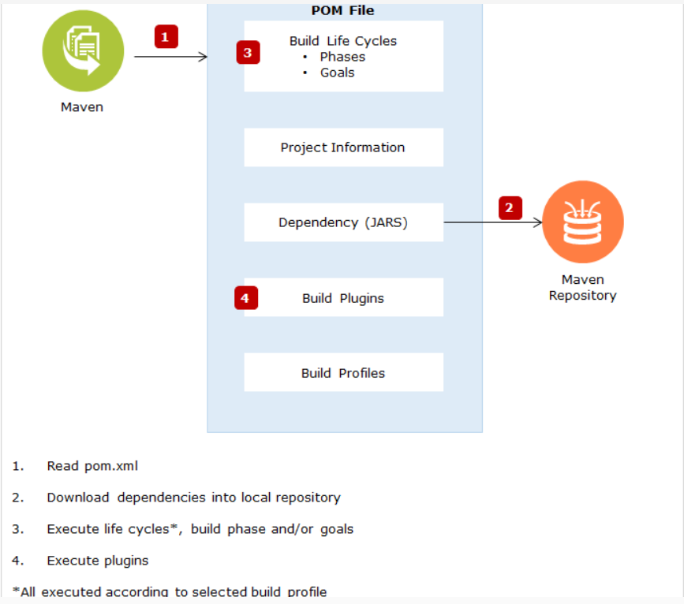

POM’s Unique Co-ordinates:
Every Maven project is uniquely identified using the following set of co-ordinates:
groupId :
- This element normally has a group name or organization name which owns the project
- Typically, the naming convention followed is the reverse of the organization's domain name. For example,
  - com.infosys.demos - contains the list of all related projects owned by Infosys
  - org.apache - contains the list of all related projects owned by apache
artifactId: This element gives information about the name of the application. eg: Infycart
version:
- This element reveals the version of the distribution unit (jar/war/ear).
  - “SNAPSHOT” is the general convention used to mention that the project is in active development phase. eg: infycart-0.0.1 - SNAPSHOT.jar
  - RELEASE is the convention used to mention that the build of the project is the base-lined, stable version. eg: Spring Context - 4.3.14.RELEASE.jar
packaging: This element decides the type of the distribution unit. eg: jar/war/ear etc.
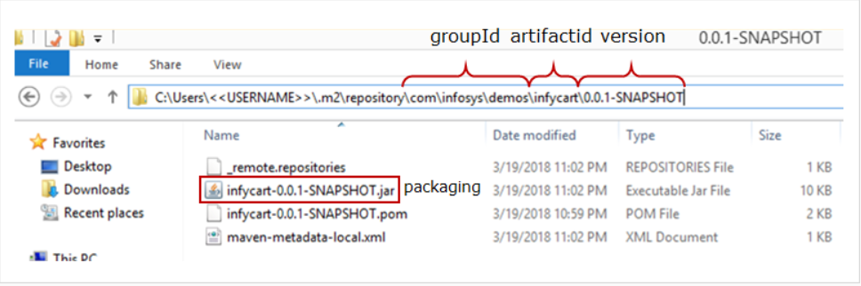

We have added the necessary dependencies for our Infycart application. Let us understand the transitive dependency management feature of Maven.
Let us consider a situation, where JUnit version of Infycart project has to be changed from 3.8.1 to 4.12 which happens to be the latest version available. The pom.xml looks as shown below:
But, JUnit 4.12.jar is transitively dependent on hamcrest-core-1.3.jar to work properly. Observe that hamcrest-core.jar is not added explicitly in the dependency section of pom.xml.
Maven not only downloads JUnit 4.12.jar but also downloads hamcrest-1.3.jar and makes it available in local repository.
This feature is termed as transitive dependency management and it happens to be one of the most desired features of Maven. It is exactly for this reason that developers prefer Maven as a popular build tool in their application development.
The clean life-cycle is associated with cleaning the previous build of a project to make it ready for the next build. The three phases that comprise clean life-cycle are as follows:
Phase | Description
pre-clean | executes tasks required prior to the actual cleaning of project
clean | remove the outcomes generated by the previous build - target folder
post-clean | execute tasks required to finalize the project cleaning

Now, let us understand the default life-cycle of Maven.
Default is Maven’s primary life-cycle that is used to build any Maven project. It comprises of twenty-three phases and the most important phases are listed below:
Phase | Description
validate | Checks for the correctness of the project and all the information that is required for a project build. For example, it verifies whether pom.xml is available in the project’s root
compile | Compiles the .java files of the project and the .class files are placed in ${basedir}/target folder
test | Executes the unit test cases available in the project and captures the result in .txt & .xml format in addition to printing the results onto the console. These reports can be viewed inside ${basedir}/target/surefire-reports folder
package | Packages the compiled code along with the required resources in a distributable format (JAR/WAR/EAR). This packaged unit is available inside ${basedir}/target folder
verify | Run checks on the integration test results to make sure that the quality criteria are met
install | Pushes the package/distribution unit to the local repository so that the package can be used as a dependency for other local projects
deploy | Pushes the build unit to the remote repository for being shared with other developers and projects
Execution of all these phases in addition to the remaining phases, in sequence, will lead to the project build.
Site life-cycle is responsible for creating site for the purpose of documenting the project, creating reports, etc. The phases of site life-cycle are as follows:
Phase | Description
pre-site | execute tasks needed prior to the actual project site generation
site | generate the project's site documentation
post-site | execute processes needed to finalize the site generation, and to prepare for site deployment
site-deploy | deploy the generated site documentation to the specified web server

Spring Framework
CustomerServiceImpl.java
- public class CustomerServiceImpl implements CustomerService{

- CustomerRepository customerRepository= new CustomerRepositoryImpl();

- public String createCustomer(CustomerDto dto) {
- return customerRepository.createCustomer(dto);

- }

- public String fetchCustomer() {
- return customerRepository.fetchCustomer();
- }
- }
In this implementation, CustomeServiceImpl depends on CustomerRepository. It also instantiates CustomerRepositoryImpl class which makes it tightly coupled with CustomerRepositoryImpl class. This is a bad design because of the following reasons:
- If you want to unit test for createCustomer() method then you need a mock object of CustomerRepository. But you cannot use a mock object because there is no way to substitute the CustomerRepositoryImpl object that CustomerServiceImpl has. So, testing CustomerServiceImpl becomes difficult.
- Also, you cannot use a different implementation of CustomerRepository other than CustomerRepositoryImpl because of tight coupling.
This solution is more flexible and easier to test. But at the same time, it is tedious to manually wire together with the dependencies. Also, if you alter the dependencies you may have to change vast amounts of code. So, what is the solution?
We can use a technique called Dependency Injection (DI). It is a technique in which the responsibility of creating and wiring the dependencies of a dependent class is externalized to the external framework or library called dependency injection (DI) frameworks. So now the control over the construction and wiring of an object graph is no longer resides with the dependent classes themselves. This reversal of responsibilities is known as Inversion of Control (IoC). Dependency injection framework also called IoC containers.
There are many third-party frameworks that are available for dependency injection such as Spring Framework, Google Guice, Play Framework, etc. In this course, you will study about Spring Framework. Besides dependency injection, there are many other advantages of using the Spring Framework which you will study later in this course.
Note: Inversion of Control (IoC) represents the inversion of application responsibility of the object's creation, initialization, dependency, and destruction from the application to the third party.

The following are the main features of the Spring Framework.
Spring Feature | Description
Light Weight | Spring JARs are relatively small.  A basic Spring framework would be lesser than 10MB.  It can be deployed in Tomcat and they do not require heavy-weight application servers.
Non-Invasive | The application is developed using POJOs.  No need to extend/implement any pre-defined classes.
Loosely Coupled | Spring features like Dependency Injection and Aspect Oriented Programming help in loosely coupled code.
Inversion of Control(IoC) | IoC takes care of the application object's life cycle along with their dependencies.
Spring Container | Spring Container takes care of object creation, initialization, and managing object dependencies.
Aspect Oriented Programming(AOP) | Promotes separation of supporting functions(concerns) such as logging, transaction, and security from the core business logic of the application.

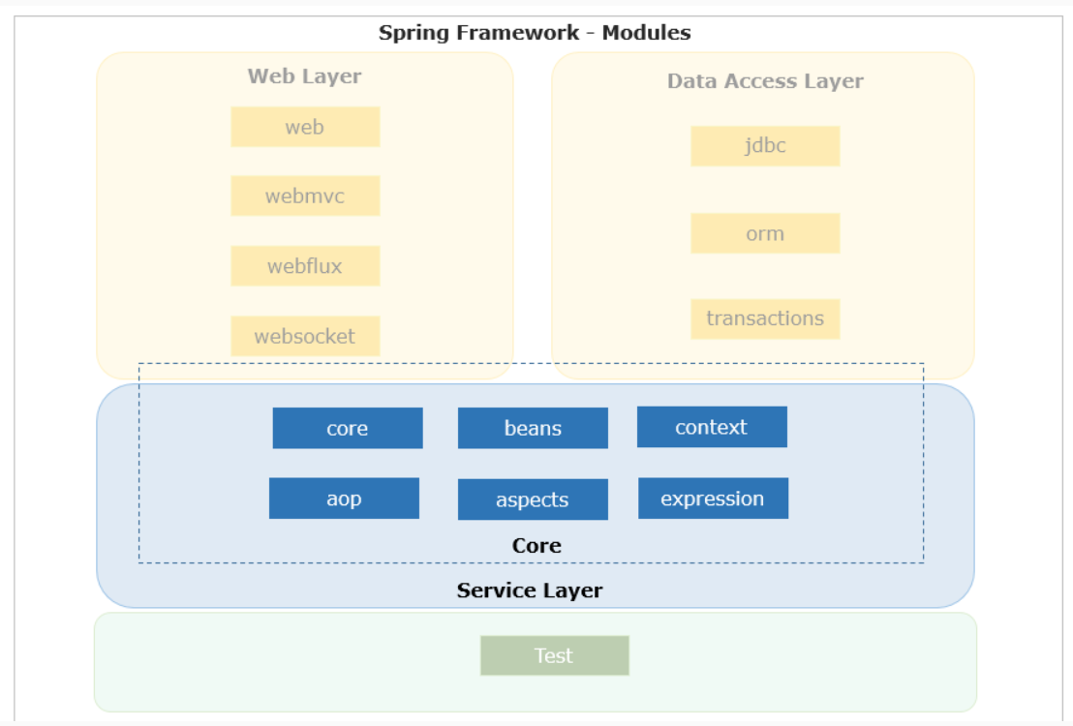
Core container has the following modules:
- Core: This is the key module of Spring Framework which provides fundamental support on which all other modules of the framework are dependent.
- Bean: This module provides a basic Spring container called BeanFactory.
- Context: This module provides one more Spring container called ApplicationContext which inherits the basic features of the BeanFactory container and also provides additional features to support enterprise application development.
- Spring Expression Language (SpEL): This module is used for querying/manipulating object values.
- AOP (Aspect Oriented Programming) and aspects: These modules help in isolating cross-cutting functionality from business logic.
The following modules support Data Access/Integration:
- Java Database Connectivity (JDBC): It provides an abstract layer to support JDBC calls to relational databases.
- Object Relational Mapping (ORM): It provides integration support for popular ORM(Object-Relational Mapping) solutions such as Hibernate, JPA, etc.
- Transactions: It provides a simple transaction API which abstracts the complexity of underlying repository specific transaction API's from the application.

Spring Framework provides the following modules to support web application development:
- Web: This module has a container called web application context which inherits basic features from ApplicationContext container and adds features to develop web based applications.
- Webmvc: It provides the implementation of the MVC(model-view-controller) pattern to implement the serverside presentation layer and also supports features to implement RESTful Web Services.
- WebFlux: Spring 5.0 introduced a reactive stack with a web framework called Spring WebFlux to support Reactive programming in Spring's web layer and runs on containers such as Netty, Undertow, and Servlet 3.1+.
- WebSocket: It is used for 2-way communication between client and server in WebSocket based web applications.

- Test: This module provides the required support to test Spring applications using TestNG or JUnit.

Usually it is the developer's responsibility to create the dependent application object using the new operator in an application. Hence any change in the application dependency requires code change and this results in more complexity as the application grows bigger.
Inversion of Control (IoC) helps in creating a more loosely coupled application. IoC represents the inversion of the responsibility of the application object's creation, initialization, and destruction from the application to the third party such as the framework. Now the third party takes care of application object management and dependencies thereby making an application easy to maintain, test, and reuse.
There are many approaches to implement IoC, Spring Framework provides IoC implementation using Dependency Injection(DI).
We need not create objects in dependency injection instead describe how objects should be created through configuration.
DI is a software design pattern that provides better software design to facilitate loose coupling, reuse, and ease of testing.
Benefits of Dependency Injection(DI):
- Helps to create loosely coupled application architecture facilitating re-usability and easy testing.
- Separation of responsibility by keeping code and configuration separately. Hence dependencies can be easily modified using configuration without changing the code.
- Allows to replace actual objects with mock objects for testing, this improves testability by writing simple JUnit tests that use mock objects.
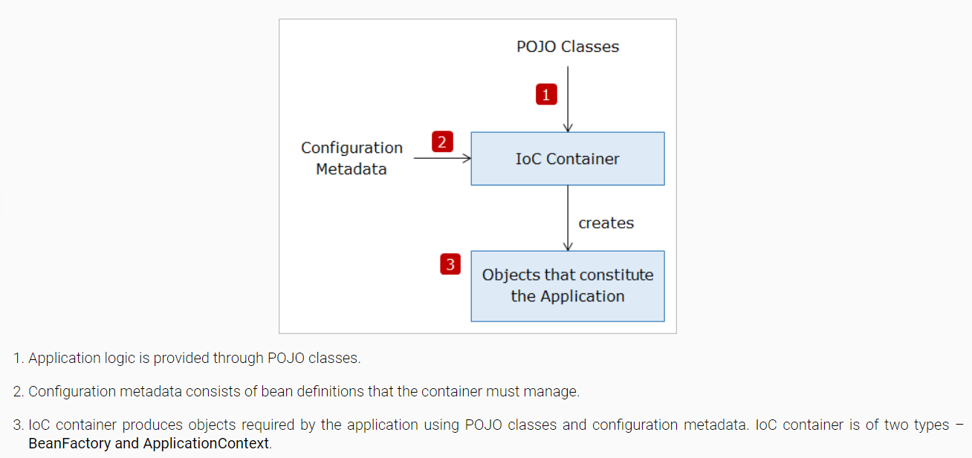

BeanFactory:
- It is the basic Spring container with features to instantiate, configure and manage the beans.
- org.springframework.beans.factory.BeanFactory is the main interface representing a BeanFactory container.
ApplicationContext:
- ApplicationContext is another Spring container that is more commonly used in Spring applications.
- org.springframework.context.ApplicationContext is the main Interface representing an ApplicationContext container.
- It inherits the BeanFactory features and provides added features to support enterprise services such as internationalization, validation, etc.
ApplicationContext is the preferred container for Spring application development.
Let us now understand the differences between BeanFactory and ApplicationContext containers.

BeanFactory | ApplicationContext
It does not support annotation-based Dependency Injection. | Support annotation-based Dependency Injection.
It does not support enterprise services. | Support enterprise services such as validations, internationalization, etc.
By default, it supports Lazy Loading. | By default, it supports Eager Loading. Beans are instantiated during load time.
//Loading BeanFactory  BeanFactory factory = new AnnotationConfigApplicationContext(SpringConfiguration.class);  // Instantiating bean during first access using getBean()  CustomerServiceImpl service = (CustomerServiceImpl) factory.getBean("customerService"); | // Loading ApplicationContext and instantiating bean  ApplicationContext context = new AnnotationConfigApplicationContext(SpringConfiguration.class);  // Instantiating bean during first access using getBean()  CustomerServiceImpl service = (CustomerServiceImpl) context.getBean("customerService");

org.springframework.context.annotation.AnnotationConfigApplicationContext is one of the most commonly used implementation of ApplicationContext.

Example: ApplicationContext container instantiation.
- ApplicationContext context = new AnnotationConfigApplicationContext(SpringConfiguration.class);
- Object obj = context.getBean("customerService");
- ApplicationContext container is instantiated by loading the configuration from the SpringConfiguration.class which is available in the utility package of the application.
- Accessing the bean with id "customerService" from the container.
AbstractApplicationContext
You can see a warning message as Resource leak: 'context' is never closed while using the ApplicationContext type. This is for the reason that you don’t have a close method with BeanFactory or even ApplicationContext. AbstractApplicationContext is an abstract implementation of the ApplicationContext interface and it implements Closeable and AutoCloseable interfaces. To close the application context and destroy all beans in its abstractApplicationContext has a close method that closes this application context.

There are different ways to access bean in Spring
1. The traditional way of accessing bean based on bean id with explicit typecast
- CustomerServiceImpl service = (CustomerServiceImpl) context.getBean("customerService");
2. Accessing bean based on class type to avoid typecast if there is a unique bean of type in the container
- CustomerServiceImpl service = context.getBean(CustomerServiceImpl.class);

3. Accessing bean through bean id and also type to avoid explicit typecast
- CustomerServiceImpl service = context.getBean("customerService", CustomerServiceImpl.class);

Spring allows providing the configuration metadata using :
- XML Configuration
- Annotation Based configuration
- Java Based configuration
The Java-based configuration metadata is provided in the Java class using the following annotations:
@Configuration: The Java configuration class is marked with this annotation. This annotation identifies this as a configuration class, and it’s expected to contain details on beans that are to be created in the Spring application context.
@Bean: This annotation is used to declare a bean. The methods of configuration class that creates an instance of the desired bean are annotated with this annotation. These methods are called by the Spring containers during bootstrap and the values returned by these methods are treated as Spring beans. By default, only one bean instance is created for a bean definition by the Spring Container, and that instance is used by the container for the whole application lifetime.
For example, the SpringConfiguration class can be configured in a Java class using the above annotations as follows:
- @Configuration

- public class SpringConfiguration {

- @Bean
- public CustomerServiceImpl customerService() {

- return new CustomerServiceImpl();
- }
- }

By default, the bean name is the same as the name of the method in which the bean is configured. So, in the above code bean name is customerService. If you want to change the bean name then you can either rename the method or provide a different name with the name attribute as follows:
- @Configuration
- public class SpringConfiguration {

- @Bean(name="service")
- public CustomerServiceImpl customerService() {

- return new CustomerServiceImpl();
- }
- }

How do we initialize beans with some specific values in Spring?
This can be achieved through Dependency Injection in Spring.
Inversion of Control pattern is achieved through Dependency Injection (DI) in Spring. In Dependency Injection, the developer need not create the objects but specify how they should be created through configuration.
Spring container uses one of these two ways to initialize the properties:
- Constructor Injection: This is achieved when the container invokes a parameterized constructor to initialize the properties of a class
- Setter Injection: This is achieved when the container invokes setter methods of a class to initialize the properties after invoking a default constructor.
Let us consider the CustomerService class of InfyTel Customer application to understand constructor injection.
CustomerService class has a count property, let us now modify this class to initialize count property during bean instantiation using the constructor injection approach.
- package com.infy.service;

- public class CustomerServiceImpl implements CustomerService {
- private int count;

- public CustomerServiceImpl(int count) {
- this.count = count;
- }

- }
How do we define bean in the configuration to initialize values?
- @Configuration
- public class SpringConfiguration {
- @Bean // CustomerService bean definition with bean dependencies through constructor injection
- public CustomerServiceImpl customerService() {
- return new CustomerServiceImpl(20);
- }
What is mandatory for constructor injection?
A parameterized constructor is required in the CustomerService class as we are injecting the values through the constructor argument.
Can we use constructor injection to initialize multiple properties?
Yes, we can initialize more than one property.
So far, we learned how to inject primitive values using constructor injection in Spring. Now we will look into inject object dependencies using Constructor injection.
Consider our InfyTel Customer application. CustomerServiceImpl.java class which is dependent on CustomerRepository(class used to in persistence layer to perform CRUD operations ) object type to call fetchCustomer() method.
- package com.infy.service;
- public class CustomerServiceImpl implements CustomerService {
- // CustomerServiceImpl needs to contact CustomerRepository, hence injecting the customerRepository dependency

- private CustomerRepository customerRepository;
- private int count;
- public CustomerServiceImpl() {
- }

- public CustomerServiceImpl(CustomerRepository customerRepository, int count) {
- this.customerRepository = customerRepository;
- this.count=count;
- }
- public String fetchCustomer() {
- return customerRepository.fetchCustomer(count);
- }

- public String createCustomer() {
- return customerRepository.createCustomer();
- }

- }
Observe in the above code, CustomerRepository property of CustomerSevice class has not been initialized with any value in the code. This is because Spring dependency is going to be taken care of in the configuration.
How do we inject object dependencies through configuration using constructor injection?
- package com.infy.util;

- @Configuration
- public class SpringConfiguration {

- @Bean// customerRepository bean definition
- public CustomerRepository customerRepository() {
- return new CustomerRepository();
- }

- @Bean // CustomerServic bean definition with bean dependencies through constructor injection
- public CustomerServiceImpl customerService() {

- return new CustomerServiceImpl(customerRepository(),20);
- }
- }

Let us now understand Setter Injection in Spring.
In Setter Injection, Spring invokes setter methods of a class to initialize the properties after invoking a default constructor.
How can we use setter injection to inject values for the primitive type of properties?
Consider the below example to understand setter injection for primitive types.
Following the CustomerServiceImpl class has a count property, let us see how to initialize this property during bean instantiation using the setter injection approach.
- package com.infy.service;
- public class CustomerServiceImpl implements CustomerService {
- private int count;
- public int getCount() {
- return count;
- }
- public void setCount(int count) {
- this.count = count;
- }
- public CustomerServiceImpl(){
- }
- }
How do we define bean in the configuration to initialize values?
- package com.infy.util;
- @Configuration

- public class SpringConfiguration {

- @Bean // CustomerService bean definition using Setter Injection
- public CustomerServiceImpl customerService() {
- CustomerServiceImpl customerService = new CustomerServiceImpl();
- customerService.setCount(10);
- return customerService;
- }
- }
What is mandatory to implement setter injection?
- Default constructor and setter methods of respective dependent properties are required in the CustomerServiceImpl class. For setter injection, Spring internally uses the default constructor to create a bean and then invokes a setter method of the respective property based on the name attribute in order to initialize the values.
So far, we learned how to inject primitive values using setter injection in Spring.
How do we inject object dependencies using setter injection?
Consider the CustomerServiceImpl class of InfyTel Customer application.
- package com.infy.service;
- public class CustomerServiceImpl implements CustomerService {
- private CustomerRepository customerRepository;
- private int count;

- public CustomerRepository getCustomerRepository() {
- return customerRepository;
- }

- public void setCustomerRepository(CustomerRepository customerRepository) {
- this.customerRepository = customerRepository;
- }

- public int getCount() {
- return count;
- }

- public void setCount(int count) {
- this.count = count;
- }

- }

How do we inject object dependencies through configuration using setter injection?
- package com.infy.util;
- @Configuration

- public class SpringConfiguration {

- @Bean
- public CustomerRepository customerRepository() {
- return new CustomerRepository();
- }

- @Bean // Setter Injection
- public CustomerServiceImpl customerService() {
- CustomerServiceImpl customerService = new CustomerServiceImpl();
- customerService.setCount(10);
- customerService.setCustomerRepository(customerRepository());
- return customerService;
- }
- }

As discussed in the previous example as a developer you have to declare all the bean definition in SpringConfiguration class so that Spring container can detect and register your beans as below :
- @Configuration
- public class SpringConfiguration {
- @Bean
- public CustomerRepository customerRepository() {
- return new CustomerRepository();
- }
- @Bean
- public CustomerServiceImpl customerService() {

- return new CustomerServiceImpl();
- }
- }
Is any other way to eliminate this tedious bean declaration?
Yes, Spring provides a way to automatically detect the beans to be injected and avoid even the bean definitions within the Spring configuration file through Auto Scanning. In Auto Scanning, Spring Framework automatically scans, detects, and instantiates the beans from the specified base package, if there is no declaration for the beans in the SpringConfiguration class.
So, your SpringConfiguration class will be looking as below:
- @Configuration
- @ComponentScan(basePackages="com.infy")
- public class SpringConfiguration {

- }

Component scanning isn’t turned on by default, however. You have to annotate the configuration class with @ComponentScan annotation to enable component scanning as follows:
- @Configuration
- @ComponentScan
- public class SpringConfiguration {
- }

In the above code, Spring will scan the package that contains SpringConfig class and it subpackages for beans. But if you want to scan a different package or multiple packages then you can specify this with the basePackages attribute as follows:
- @Configuration
- @ComponentScan(basePackages = "com.infy.service,com.infy.repository")
- public class SpringConfiguration {
- }

Spring uses @ComponentScan annotation for the auto scan feature. It looks for classes with the stereotype annotations and creates beans for such classes automatically.
So, what are Stereotype annotations?
- Stereotype annotations denote the roles of types or methods at the conceptual level.
- Stereotype annotations are @Component, @Service, @Repository, and @Controller annotations.
- These annotations are used for auto-detection of beans using @ComponentScan.
- The Spring stereotype @Component is the parent stereotype.
- The other stereotypes are the specialization of @Component annotation.
Annotation | Usage
@Component | It indicates the class(POJO class) as a Spring component.
@Service | It indicates the Service class(POJO class) in the business layer.
@Repository | It indicates the Repository class(POJO class in Spring DATA) in the persistence layer.
@Controller | It indicates the Controller class(POJO class in Spring MVC) in the presentation layer.
- @Component is a generic stereotype for any Spring-managed component.
- @Repository, @Service, and @Controller are specializations of @Component for more specific use cases.
- @Component should be used when your class does not fall into either of three categories i.e. Controllers, Services, and DAOs.

By default, the bean names are derived from class names with a lowercase initial character. Therefore, your above defined beans have the names customerController, customerServiceImpl, and customerRepositoryImpl. It is also possible to give a specific name with a value attribute in those annotations as follows:
- ​@Repository(value="customerRepository")
- public class CustomerRepositoryImpl implements CustomerRepository {
- //rest of the code
- }

Note: As a best practice, use @Service for the service layer, @Controller for the Presentation layer, and @Repository for the Persistence layer.

So far you have learned that Spring is a lightweight framework for developing enterprise Java applications. But using Spring for application development is challenging for developer because of the following reason which reduces productivity and increases the development time:
1. Configuration
You have seen that the Spring application requires a lot of configuration. This configuration also needs to be overridden for different environments like production, development, testing, etc. For example, the database used by the testing team may be different from the one used by the development team. So, we have to spend a lot of time writing configuration instead of writing application logic for solving business problems.
2. Project Dependency Management
When you develop a Spring application you have to search for all compatible dependencies for the Spring version that you are using and then manually configure them. If the wrong version of dependencies is selected then it will be an uphill task to solve this problem. Also, for every new feature added to the application, the appropriate dependency needs to be identified and added. All this reduces productivity.
So, to handle all these kinds of challenges Spring Boot came into the market.
What is Spring Boot?
Spring Boot is a framework built on top of the Spring framework that helps the developers to build Spring-based applications very quickly and easily. The main goal of Spring Boot is to create Spring-based applications quickly without demanding developers to write the boilerplate configuration.
But how does it work? It works because of the following reasons,
1. Spring Boot is an opinionated framework
Spring Boot forms opinions. It means that Spring Boot has some sensible defaults which you can use to quickly build your application. For example, Spring Boot uses embedded Tomcat as the default web container.
2. Spring Boot is customizable
Though Spring Boot has its defaults, you can easily customize it at any time during your development based on your needs. For example, if you prefer log4j for logging over Spring Boot built-in logging support then you can easily make a dependency change in your pom.xml file to replace the default logger with log4j dependencies.
The main Spring Boot features are as follows:
- Starter Dependencies
- Automatic Configuration
- Spring Boot Actuator
- Easy-to-use Embedded Servlet Container Support

DemoSpringBootApplication.java
- @SpringBootApplication
- public class DemoSpringBootApplication {
- public static void main(String[] args) {
- SpringApplication.run(DemoSpringBootApplication.class, args);
- }
- }

It is annotated with @SpringBootApplication annotation which triggers auto-configuration and component scanning and can be used to declare one or more @Bean methods also. It contains the main method which bootstraps the application by calling the run() method on the SpringApplication class. The run method accepts DemoSpringBootApplication.class as a parameter to tell Spring Boot that this is the primary component.

- <dependency>
- <groupId>org.springframework.boot</groupId>
- <artifactId>spring-boot-starter</artifactId>
- </dependency>

Spring Boot comes with many starters. Some popular starters which we are going to use in this course are as follows:
- spring-boot-starter - This is the core starter that includes support for auto-configuration, logging, and YAML.
- spring-boot-starter-aop - This starter is used for aspect-oriented programming with Spring AOP and AspectJ.
- spring-boot-starter-data-jdbc - This starter is used for Spring Data JDBC.
- spring-boot-starter-data-jpa - This starter is used for Spring Data JPA with Hibernate.
- spring-boot-starter-web - This starter is used for building a web application using Spring MVC and Spring REST. It also provides Tomcat as the default embedded container.
- spring-boot-starter-test - This starter provides support for testing Spring Boot applications using libraries such as JUnit, Hamcrest, and Mockito.

You can use other files to keep the properties. For example, InfyTelmessage.properties.
InfyTelmessage.properties
- message=Welcome To InfyTel
But by default Spring Boot will load only the application.properties file. So how you will load the InfyTelmessage.properties file?
In Spring @PropertySource annotation is used to read from properties file using Spring’s Environment interface. The location of the properties file is mentioned in the Spring configuration file using @PropertySource annotation.
So InfyTelmessage.properties which are present in classpath can be loaded using @PropertySource as follows:

- import org.springframework.context.annotation.PropertySource;

- @SpringBootApplication
- @PropertySource("classpath:InfyTelmessage.properties")
- public class DemoSpringBootApplication {

- public static void main(String[] args) throws Exception {
- //code
- }
- }

We have already learned that the class which is used to bootstrap the Spring Boot application is annotated with @SpringBootApplication annotation as follows:
- @SpringBootApplication
- public class DemoSpringBootApplication {
- public static void main(String[] args) {
- SpringApplication.run(DemoSpringBootApplication.class, args);
- }
- }

Now let us understand this annotation in detail.
The @SpringBootApplication annotation indicates that it is a configuration class and also triggers auto-configuration and component scanning. It is a combination of the following annotations with their default attributes:
@EnableAutoConfiguration – This annotation enables auto-configuration for the Spring boot application which automatically configures our application based on the dependencies that you have added.
@ComponentScan – This enables the Spring bean dependency injection feature by using @Autowired annotation. All application components which are annotated with @Component, @Service, @Repository, or @Controller are automatically registered as Spring Beans. These beans can be injected by using @Autowired annotation.
@Configuration – This enables Java based configurations for Spring boot application.
The class that is annotated with @SpringBootApplication will be considered as the main class, is also a bootstrap class. It kicks starts the application by invoking the SpringApplication.run() method. You need to pass the .class file name of your main class to the run() method.
SpringBootApplication- scanBasePackages
By default, SpringApplication scans the configuration class package and all it’s sub-packages. So if our SpringBootApplication class is in "com.eta" package, then it won’t scan com.infy.service or com.infy.repository package. We can fix this situation using the SpringBootApplication scanBasePackages property.
- package com.eta;
- @SpringBootApplication(scanBasePackages={"com.infy.service","com.infy.repository"})

- public class DemoSpringBootApplication {
- public static void main(String[] args) {
- SpringApplication.run(DemoSpringBootApplication.class, args);
- }
- }

In Spring if one bean class is dependent on another bean class then the bean dependencies need to be explicitly defined in your configuration class. But you can let the Spring IoC container to inject the dependencies into dependent bean classes without been defined in your configuration class. This is called as autowiring.
To do autowiring, you can use @Autowired annotation. This annotation allows the Spring IoC container to resolve and inject dependencies into your bean.@Autowired annotation performs byType Autowiring i.e. dependency is injected based on bean type. It can be applied to attributes, constructors, setter methods of a bean class.
Autowiring is done only for dependencies to other beans. It doesn't work for properties such as primitive data types, String, Enum, etc. For such properties, you can use the @Value annotation.
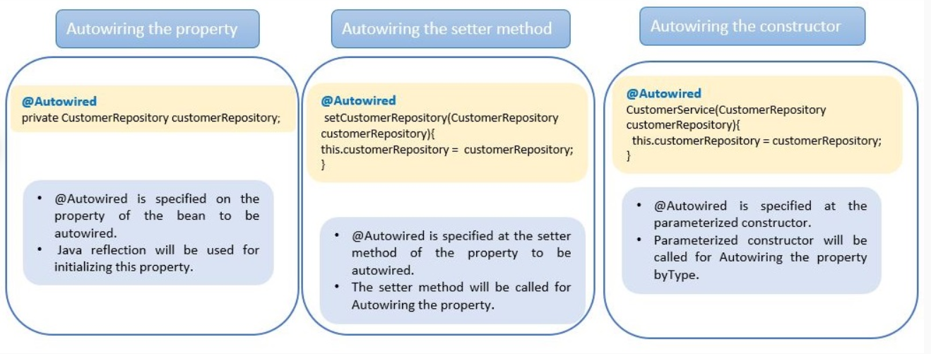
@Autowired on Setter methods
The @Autowired annotation can be used on setter methods. This is called a Setter Injection.
- package com.infy.service;
- public class CustomerServiceImpl implements CustomerService {

- private CustomerRepository customerRepository;

- @Autowired
- public void setCustomerRepository(CustomerRepository customerRepository) {
- this.customerRepository = customerRepository;
- }
- --------
- }
@Autowired on Constructor
The @Autowired annotation can also be used on the constructor. This is called a Constructor Injection.
- package com.infy.service;
- public class CustomerServiceImpl implements CustomerService {

- private CustomerRepository customerRepository;

- @Autowired
- public CustomerServiceImpl(CustomerRepository customerRepository) {
- this.customerRepository = customerRepository;
- }
- --------------
- }
@Autowired on Properties
Let us now understand the usage of @Autowired on a property in Spring.
We will use @Autowired in the below code to wire the dependency of CustomerService class for CustomerRepository bean dependency.
- package com.infy.service;
- public class CustomerServiceImpl {
- // CustomerService needs to contact CustomerRepository, hence injecting the customerRepository dependency
- @Autowired
- private CustomerRepository customerRepository;
- ------------
- }
@Autowired is by default wire the dependency based on the type of bean.
In the above code, the Spring container will perform dependency injection using the Java Reflection API. It will search for the class which implements CustomerRepository and injects its object. The dependencies which are injected using @Autowired should be available to the Spring container when the dependent bean object is created. If the container does not find a bean for autowiring, it will throw the NoSuchBeanDefinitionException exception.
If more than one beans of the same type are available in the container, then the framework throws an exception indicating that more than one bean is available for autowiring. To handle this @Qualifier annotation is used as follows:
- package com.infy.service;
- public class CustomerServiceImpl {

- @Autowired
- @Qualifier("custRepo")
- private CustomerRepository customerRepository;
- ------------
- }

In Spring @Value annotation is used to insert values into variables and method arguments. Using @Value we can either read spring environment variables or system variables.
We can assign a default value to a class property with @Value annotation:
- public class CustomerDTO {
- @Value("1234567891")
- long phoneNo;
- @Value("Jack")
- String name;
- @Value("Jack@xyz.com")
- String email;
- @Value("ANZ")
- String address;
- }
Note that it accepts only a String argument but the passed-in value gets converted to an appropriate type during value-injection.
To read a Spring environment variable we can use @Value annotation:
- public class CustomerDTO {
- @Value("${value.phone}")
- long phoneNo;
- @Value("${value.name}")
- String name;
- @Value("${value.email}")
- String email;
- @Value("${value.address}")
- String address;
- }

Bean LifeCycle

The lifetime of a bean depends on its scope. Bean's scope can be defined while declaring it in the configuration metadata file.
A bean can be in singleton or prototype scope. A bean with the "singleton" scope is initialized during the container starts up and the same bean instance is provided for every bean request from the application. However, in the case of the "prototype" scope, a new bean instance is created for every bean request from the application.
There will be a single instance of "singleton" scope bean in the container and the same bean is given for every request from the application.
The bean scope can be defined for a bean using @Scope annotation in Java class. By default, the scope of a bean is the singleton
- package com.infy.service;

- @Service("customerService")
- @Scope("singleton")
- public class CustomerServiceImpl implements CustomerService {
- @Value("10")
- private int count;

- public int getCount() {
- return count;
- }

- public void setCount(int count) {
- this.count = count;
- }

- public String fetchCustomer() {
- return " The number of customers fetched are : " + count;
- }

- }

For the "prototype" bean, there will be a new bean created for every request from the application.
In the below example, customerService bean is defined with prototype scope. There will be a new customerService bean created for every bean request from the application.
- package com.infy.service;

- import org.springframework.beans.factory.annotation.Value;
- import org.springframework.context.annotation.Scope;
- import org.springframework.stereotype.Service;

- @Service("customerService")
- @Scope("prototype")
- public class CustomerServiceImpl implements CustomerService {
- @Value("10")
- private int count;

- public int getCount() {
- return count;
- }

- public void setCount(int count) {
- this.count = count;
- }

- public String fetchCustomer() {
- return " The number of customers fetched are : " + count;
- }

- }

Logging
What is logging?
Logging is the process of writing log messages to a central location during the execution of the program. That means Logging is the process of tracking the execution of a program, where
- Any event can be logged based on the interest to the
- When exception and error occur, we can record those relevant messages and those logs can be analyzed by the programmer later
There are multiple reasons why we may need to capture the application activity.
- Recording unusual circumstances or errors that may be happening in the program
- Getting the info about what's going in the application
AOP (Aspect Oriented Programming) is used for applying common behaviors like transactions, security, logging, etc. to the application.
These common behaviors generally need to be called from multiple locations in an application. Hence, they are also called as cross cutting concerns in AOP.
Spring AOP provides the solution to cross cutting concerns in a modularized and loosely coupled way.
Advantages
- AOP ensures that cross cutting concerns are kept separate from the core business logic.
- Based on the configurations provided, the Spring applies cross cutting concerns appropriately during the program execution.
- This allows creating a more loosely coupled application wherein you can change the cross-cutting concerns code without affecting the business code.
- In Object Oriented Programming (OOP), the key unit of modularity is class. But in AOP the key unit of modularity is an Aspect.
What is an Aspect?
Aspects are the cross-cutting concerns that cut across multiple classes.
Examples: Transaction Management, Logging, Security, etc.
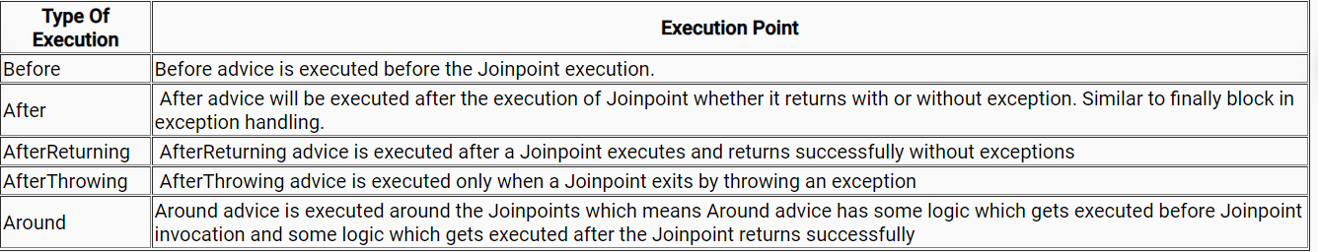
- In Spring AOP, we need to modularize and define each of the cross-cutting concerns in a single class called Aspect.
- Each method of the Aspect which provides the implementation for the cross-cutting concern is called Advice.
- The business methods of the program before or after which the advice can be called is known as a Joinpoint.
- The advice does not get inserted at every Joinpoint in the program.
- An Advice gets applied only to the Joinpoints that satisfy the Pointcut defined for the advice.
- Pointcut represents an expression that evaluates the business method name before or after which the advice needs to be called.
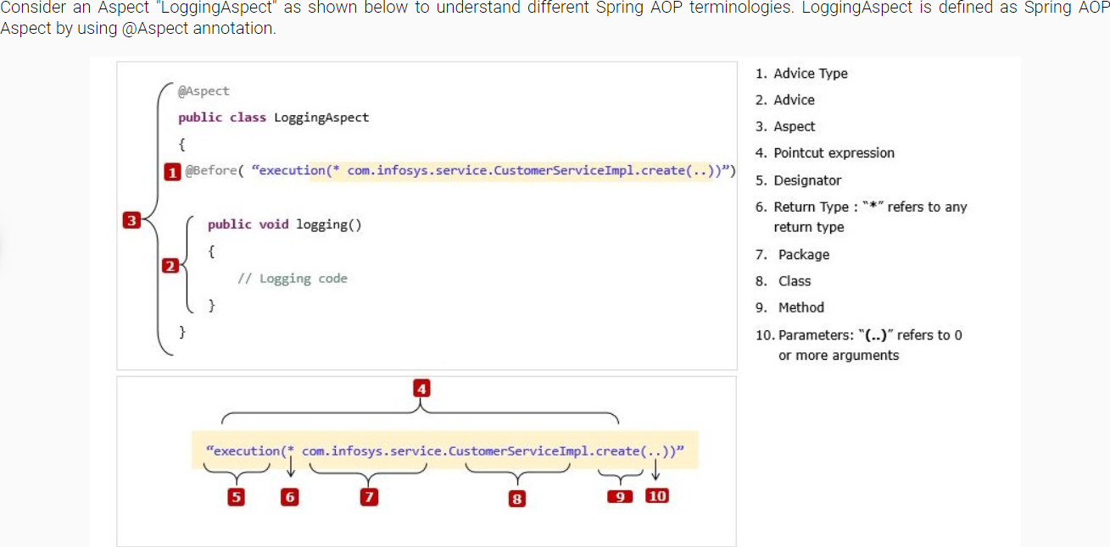

Spring Profiles
You can identify the Spring beans which have to be part of a profile using the following ways
1)Annotation @Profile
2) Bean declaration in XML
@Profile helps spring to identify the beans that belong to a particular environment.
- Any class which is annotated with stereotype annotations such as @Component,@Service,@Repository and @Configuration can be annotated with @Profile .
- @Profile is applied at class level except for the classes annotated with @Configuration where @Profile is applied at the method level.
@Profile- Class level:
- @Profile("dev")
- @Component
- @Aspect
- public class LoggingAspect { }

This LoggingAspect class will run only if “dev” environment is active.
@Profile- Method level:
- @Configuration
- public class SpringConfiguration {

- @Bean("customerService")
- @Profile("dev")
- public CustomerService customerServiceDev() {
- CustomerService customerServiceDev= new CustomerService();
- customerServiceDev.setName("Developement-Customer");
- return customerServiceDev;
- }

- @Bean("customerService")
- @Profile("prod")
- public CustomerService customerServiceProd() {
- CustomerService customerServiceProd=new CustomerService();
- customerServiceProd.setName("Production-Customer");
- return customerServiceProd;
- }
- }

In the above code snippet CustomerService bean is configured differently in the "dev" and "prod" environments. Depending on the currently active profile Spring fetches CustomerService accordingly.
Note: @Profile annotation in class level should not be overridden in the method level. It will cause “NoSuchBeanDefinitionException”.
@Profile value can be prefixed with !(Not) operator.
- @Profile("!test")
- @Configuration
- @ComponentScan(basePackages="com.infy.service")
- public class SpringConfiguration { }

This SpringConfiguration class will run in all environments other than test.
Note:
if you don't apply @profile annotation on a class, means that the particular bean is available in all environment(s).
Spring Boot relies on application.properties file for configuration. To write configuration based on environment, you need to create different application.properties files. The file name has a naming convention as application-<user created profile name>.properties
Example:
application-dev.properties
- # Oracle settings
- spring.datasource.url=jdbc:oracle:thin:@localhost:1522:devDB
- spring.datasource.username=root
- spring.datasource.password=root
- spring.datasource.driver.class=oracle.jdbc.driver.OracleDriver

- # logging
- logging.pattern.file= %d{yyyy-MM-dd HH:mm:ss} [%thread] %-5level %logger{36} - %msg%
- logging.level.org.springframework.web: ERROR

application-test.properties
- # Oracle settings
- spring.datasource.url=jdbc:oracle:thin:@localhost:1522:testDB
- spring.datasource.username=root
- spring.datasource.password=root
- spring.datasource.driver.class=oracle.jdbc.driver.OracleDriver

- # logging
- logging.pattern.file= %d{yyyy-MM-dd HH:mm:ss} [%thread] %-5level %logger{36} - %msg%
- logging.pattern.console=%d{yyyy-MM-dd HH:mm:ss} - %msg%n
- logging.level.org.springframework.web: DEBUG

application-prod.properties
- # mysql settings
- spring.datasource.url=jdbc:mysql://localhost:3306/prodDB?useSSL=false
- spring.datasource.username=root
- spring.datasource.password=root
- spring.datasource.driver.class=com.mysql.jdbc.Driver

- # logging
- logging.pattern.file= %d{yyyy-MM-dd HH:mm:ss} [%thread] %-5level %logger{36} - %msg%
- logging.level.org.springframework.web: INFO

Note: The above shows how application.properties file with different configuration is created for 3 different environments(dev,test and prod)
To set an active profile you need to write the below property in the main application.properties file.
- spring.profiles.active=dev
OR
- spring.profiles.active=dev,prod

Best Practices
- Java doesn't allow annotations placed on interfaces to be inherited by the implemented class so make sure that we place the spring annotations only on class, fields, or methods.
- As a good practice place @Autowired annotation before a constructor.
We know that there are three places we can place @Autowired annotation in Spring on fields, on setter method, and on a constructor. The classes using field injection are difficult to maintain and it is very difficult to test. The classes using setter injection will make testing easy, but this has some disadvantages like it will violate encapsulation. Spring recommends that use @Autowired on constructors that are easiest to test, and the dependencies can be immutable.
- In the case of AOP as a best practice store all the Pointcuts in a common class which will help in maintaining the pointcuts in one place.
- public class CommonPointConfig {

- @Pointcut("execution(* com.infy.service.CustomerServiceImpl.fetchCustomer(..))")
- public void logAfterAdvice(JoinPoint joinPoint){}
- @Pointcut("execution(* com.infy.service.CustomerServiceImpl.fetchCustomer(..))")
- public void logBeforeAdvice(){}
- }

The above common definition can be used when defining pointcuts in other aspects.
- @Around("com.infy.service.CustomerServiceImpl.fetchCustomer.aspect.CommonPointConfig.logBeforeAdvice()")

- While defining the scope of the beans choose wisely.
If we want to create a stateless bean then singleton scope is the best choice. In case if you need a stateful bean then choose prototype scope.
- When to choose Constructor-based DI and setter-based DI in Spring /Spring boot applications
A Spring application developer can mix the Constructor injection and Setter injection in the same application but it's a good practice to use constructor injection for mandatory dependencies and Setter injection for optional dependencies.

